St. Joseph’s Catholic High School
Business & Enterprise College
Living, Loving & Learning Through Christ

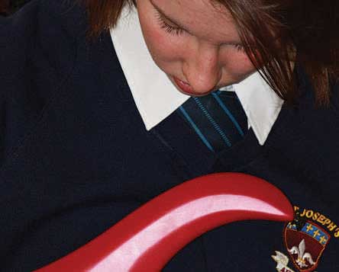
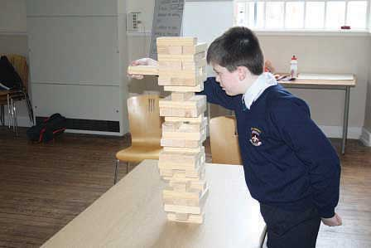
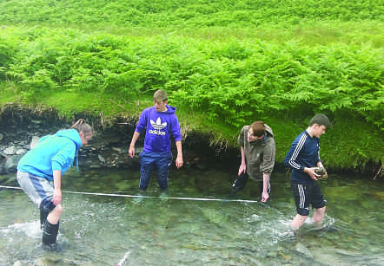
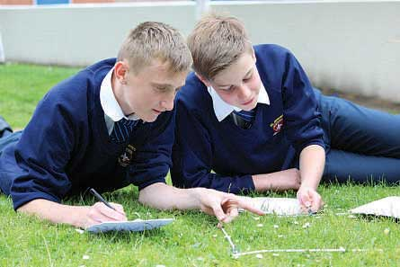

Teacher
of
Maths

St Joseph’s Catholic High School - serving the community
We seek to appoint a Maths teacher to our staff from
September 2018. This is a significant opportunity for
some one who would like to work in a “ Good”
and improving Catholic School.

Harrington Road, Workington CA14 3EE. 01900 873290
www.st-josephs.cumbria.sch.uk
Dear Colleague,

Thank you for expressing an interest in the advertised post and I hope you find the details in our application pack informative.

We wish to appoint a Maths teacher of the highest calibre who is looking to work in a Catholic school and who is willing to contribute to improving our “Good” school even further. The person appointed will be expected to work within Maths to contribute our improving results and work within a year team as a form tutor and contribute to our Catholic Ethos.

St Joseph’s was founded by our local parishioners who wanted a Catholic School for their children. After raising money St Joseph’s was established in 1929. By ensuring our Mission Statement underpins everything we do, we hope to fulfil the legacy of the families who had a vision for Catholic education in Workington almost ninety years ago.

St Joseph’s is a highly popular school; with a good reputation. In 2016, we were graded “Good” by Ofsted but outcomes were judged to be “RI”. We have worked hard to secure improvements in 2017 and there is still room for plenty of improvement. We are working hard to raise standards wherever possible and will not be satisfied until we are securely above national in all areas.

Central to everything that happens at St Joseph’s are our students. Staff have sought to ensure that every student in valued and listened to. Relationships between staff, students and parents are strong. We are proud of our “family feel.” Students appreciate very much the time that staff dedicate to them. Students know that we expect the very best in behaviour and attitudes and they respond well.

Maths is led by a member of the Extended Senior Team. The department is staffed with six teaching posts who teach in a dedicated area of school. The department work closely together to develop their skills and to ensure that every lesson is planned for progress for every child. You would be joining a team which has seen recent success and is aiming to be even more successful in the future. We are looking forward to appointing a new teacher to ensure that this goal is achieved.

If you wish to visit the school beforehand, or telephone me, please do.

Yours sincerely

Jacky Kennedy
Headteacher

St Joseph’s Catholic High School
Business & Enterprise College
Harrington Road, Workington, Cumbria CA14 3EE
Western Lake District, Cumbria
01900 873290
NOR 697 - 11-16
Head teacher Miss J Kennedy.
Teacher/s of Mathematics - September 2018

The Governors are looking to appoint an outstanding and committed professionals to join our growing Catholic school was last judged ‘Good by Ofsted.’
The successful applicant/s will join a successful, vibrant and forward thinking team lead by an excellent Leader who is a member of the extended Leadership team.
The position will be highly suitable for an NQT teacher at the start of their career. There will be many opportunities within the department to grow professionally and develop your teaching.
Candidates will teach in both key stage 3 and 4 and should be able to work as a team and on their own. Candidates should be passionate about mathematics, teaching and learning and striving to ensure every child reaches their potential.
Candidates should have at least a good A level in Mathematics and hold a numerate-based degree.
Please return your application form to Mrs J Gaffney by noon on Monday 29th January email jw@st-josephs.cumbria.sch.uk , Interviews will take pace during the week commencing the 29th January 2018.

The school is committed to safe recruitment procedures. Applicants are subject to an enhanced DBS. This is not an equal opportunities school.

ST. JOSEPHS CATHOLIC HIGH SCHOOL MATHEMATICS

This is an exciting time to be part of St. Joseph’s Catholic High School, we have recently been judged as a ‘Good’ school; the students, staff and governors are all making rapid progress towards ensuring the Mathematics department is outstanding. In order to support this vision further, we are currently seeking to appoint an inspiring and creative Teacher of Mathematics to join our hardworking and committed staff.

The Mathematics team are enthusiastic and the students enjoy their lessons and engage positively with their learning. Through high quality teaching and learning, we ensure students are well-motivated and develop a further interest and curiosity in mathematical knowledge and ideas. We ensure the development of skills, both general, and mathematics specific, which prepares students for adult life and the workplace.

As a new member of our team, we will nurture, support and challenge you in your career. By working closely within the department and with other areas in the School we will encourage you to develop your skills, pedagogy and you will be given the opportunity, when appropriate, to take a leading role on suitable initiatives to further develop your teaching. At St. Joseph’s you can expect a supportive culture within a School with very high expectations.

Department Members

Kerri Basso (Head of Department)
Victoria Hughes
John Kinsella (Assistant Head)
Jenny Kurzyk
Leoni Shields
Julie Skidmore

We also have 2 dedicated subject specific HLTAs: Anna Hornakova and Vicky Smart. The HLTA posts are funded through Pupil Premium funding therefore the focus of this work is with students who are in receipt of this funding.

Department Information
We have a 2 year Key Stage 3 course and a 3 year Key Stage 4 course.

Year 7 classes receive 4 lessons per week (each lasting 50 minutes) and Year 8 classes receive 5 lessons per week.

We have numeracy lessons timetabled in addition to the maths curriculum time for the lowest attainers; this is delivered jointly between the maths and learning support department. We have an established catch-up numeracy programme for students entering the school below the National average.

We have a successful and established transition process in Maths; we have dedicated members of the Maths team who organise and deliver transition events. We are recognised as a PFEG Centre of Excellence and are integral in organising and delivering financial capabilities in Maths lessons and throughout the year during our student’s personal development days. Our financial capabilities work is a vital area of the transition work.

All Key Stage 4 classes receive 5 lessons per week. The Key Stage 4 curriculum is designed to reflect the change of emphasis in mathematics teaching set out in the new GCSE.

Throughout both Key Stages, we are focused on delivering high quality teaching, leading to solid learning, progress and outcomes. We are all reflective practitioners and we work together to further improve our practice; this is aided by our CPD programme. We have close links with AQA and host several of their CPD sessions per year. We are active members of the West Coast Teaching Schools Alliance. We are a forward thinking team and have a clear vision in order to become an outstanding department.

Schemes of Work
The schemes of work for KS3 and 4 are continually developed and reflected upon; they have the overall aim to ensure that lessons maximise the opportunities for all students to consolidate their knowledge and understanding and provide the opportunity for every child to be stretched. We have very high expectations for all students and the schemes of work mirror this.

Assessment
Each student in Key Stage 3 completes a formal assessment every term. This allows accurate tracking and ensures interventions are timely, appropriate and effective. Students also sit a formal end of year exam. In addition to the formal assessments, reflection time is built into the curriculum, ensuring results are shared with parents and clear steps for improvement are identified and acted upon.
All students within Key Stage 4 complete formal assessments at the end of each unit of work; these consist of past exam questions and are standardised and levelled according to GCSE grade boundaries. Students take full GCSE papers in the Hall to ensure exam stress is minimised. All GCSE exams are moderated by two external exam board markers, to ensure accuracy of marks and subsequently, grading.

Homework
Every student in every class is expected to complete at least one homework per week.

Accommodation
The Maths Department has a dedicated area within the school, comprising of six classrooms and two intervention rooms. We have a set of iPads, which may be used with classes or with intervention groups.

Key Stage 4 Results
 | 2011 | 2012 | 2013 | 2014 | 2015 | 2016
A* - C | 59.5 | 60.5 | 70 | 67.4 | 60.5 | 66.7
A/A* | 10 | 12.1 | 13 | 17.8 | 8.8 | 9.4

2017 GCSE Results
 | Maths | Similar Centres | National
9 – 7 | 7 | 11 | 19
9 – 5 | 36 | 38 | 49
9 – 4 | 66 | 61 | 68
9 – 1 | 98 | 98 | 98

Person Specification
 | Essential | Desirable
Qualifications/ training/ competencies | Qualified teacher status | Evidence of participation in professional development or further study
 | Relevant qualification in subject area (degree) | Practising Catholic
 | Teaching qualification (PGCE/Cert Ed)
Relevant experience | Outstanding teaching ability | Experience of dealing with a wide range of students and responding to their needs
 | Experience of effective team working and promoting effective relationships | Understanding and experience of exam board procedures and administration
 | Ability to use IT in teaching and administrative duties | Experience of teaching to A level
 | Ability to teach across the ability range in Key Stage 3 and 4
Knowledge | Knowledge and understanding of equality and diversity issues
 | Knowledge and understanding of different teaching strategies and ability to apply these appropriately
Skills | Excellent communication skills
 | Student focused
 | Flexible approach
 | Ability to manage time effectively and meet deadlines
 | Ability to demonstrate patience and understanding with learners
Personal Qualities | Commitment to actively supporting the school’s distinctive ethos
 | Ability to work as part of a team
 | Ambition and the capacity for hard work
 | Energy and imagination
 | A talent for motivating students across a range of abilities
 | Good organisational skills
 | Determination to achieve the very best result for every student

Business and Enterprise:
The school became a Business and Enterprise College in 2003 and we were re- designated as part of our Ofsted inspection in March 2009. We were awarded the ‘Centre for Excellence in Enterprise Education’ by the University of Warwick in May 2011. We were one of the first schools to receive this award in Cumbria.

Our Business and Enterprise is delivered through the curriculum where possible; as part of our Life Days and as one-off Enterprise activity days. We celebrate National Enterprise week in November through form activities; Careers talks at breakfast and lunch time; extra-curricular events after school.

We have developed many partnerships with local business and commerce that help us out with events and in curriculum areas throughout the year. We hold a work ready day with mock interviews for Year 10 pupils and Year 11 pupils.

A member of the Senior Team has taken a lead role in working with the Cumbria Enterprise Learning Partnership covering Enterprise Education from 4-19. This involved working with business commerce, Secondary, Primary School and FE Colleges. We delivered training programmes and shared best throughout to schools and Colleges throughout Cumbria. This work is on-going but in a slightly different format. A member of a staff is currently representing West Cumbria schools working on new materials around financial capability to use in both Primary and Secondary schools.

Students take part in a number of external competitions throughout the year.

GCSE Results:
Ours GCSE Results for the last 3 years are:

 | 2013/14 | 2014/15 | 2015/16
5 A*-C (EM) | 57% | 45% | 56%
Progress 8 | n/a | n/a | -0.51

Staff development/ Career development
We are part of the Western Lakes Teaching Schools Alliance and are continuing to build on the already strong links with other schools in the area. We are now into our third year where we have dedicated staff training time allocated each Thursday afternoon. This time is used for whole school training, sharing best practice and work in departments.

The development of our staff is of the highest importance and it is a strong feature of our school and many staff have benefitted from internal promotions over the years. Career development is one of our school’s priorities in the school improvement plan 2016/2017 and we will be working with each member of staff to identify where they want to be in their stage of their careers and finding opportunities to gain experience receive mentoring and training to help the individual achieve their goals.
In this post as 2nd in Mathematics you will have the opportunity to work with a Head of Department who is experienced and dynamic and she will be able to share her vision, experience and knowledge and help you to develop your career. If you are in the early stages of your career and have not had any experience of managing an area of curriculum in school, don’t worry because for the right person we are prepared to train and develop you to help you to reach your full potential.

Business and Enterprise:
The school became a Business and Enterprise College in 2003 and we were re- designated as high performing as part of our Ofsted inspection in March 2009. We were awarded the ‘Centre for Excellence in Enterprise Education’ by the University of Warwick in May 2011. We were one of the first schools to receive this award in Cumbria.

Our Business and Enterprise is delivered through the curriculum where possible; as part of our Pupil Personal Development Days and as one-off Enterprise activity days. We celebrate National Enterprise week in November through form activities; Careers talks at breakfast and lunch time; extra-curricular events after school.

We have developed many partnerships with local business and commerce that help us out with events and in curriculum areas throughout the year. We hold a work ready day with mock interviews for Year 10 pupils.

A member of the Senior Team has taken a lead role in working with the Cumbria Enterprise Learning Partnership covering Enterprise Education from 4-19. This involved working with business commerce, Secondary, Primary School and FE Colleges. We delivered training programmes and shared best throughout to schools and Colleges throughout Cumbria. This work is on-going but in a slightly different format.
Students take part in a number of external competitions throughout the year.

The Maths department play a key role in the delivery of Financial capabilities both through the subject and through delivery on Pupil Development Days.

Conditions of Service
The above responsibilities are subject to the general duties and responsibilities contained in the statement of Conditions of Employment.

These duties may be amended as necessary at the discretion of the Headteacher in light of the future development of the school.

The creation of a truly Christian environment in which the Gospel is lived and experienced by all members of its community, is the central aim of St Joseph’s. All applicants are expected to be supportive of this central aim.

Features of West Cumbria
The School is situated at the western fringe of the Lake District National Park.
Many staff choose to live locally and enjoy a rural lifestyle in towns such as Cockermouth, Keswick and the villages in West Cumbria.

Housing and rented accommodation are generally readily available at prices which are lower than urban and city locations.

The school exhibits all the advantages of a smaller comprehensive school. Children are known by name by all, standards of discipline and the quality of staff pupil relationships is excellent.
Closing date for applications is 12.00 noon 29th June 2017.

Our School Mission Statement

AT ST. JOSEPH’S CATHOLIC HIGH SCHOOL
WE WILL CHALLENGE YOU TO AIM HIGH, WE EXPECT YOU TO SUCCEED

LIVING LOVING LEARNING

All members of the school community – pupils, staff, governors and parents – will be united in sharing a common purpose: to achieve their personal best, to pursue lifelong learning, to develop and model respect for themselves and others and lay a significant role in the life of the local community; and they will be able to articulate this common purpose and support each other to achieve these goals.

LIVING LOVING LEARNING

Our School will be characterised by positive, appropriate, productive and warm relationships all of which are at the heart of our faith. We will encourage all members of the community to reflect on and develop their relationships with each other to promote tolerance and understanding.

LIVING LOVING LEARNING

All members of the school community will strive to achieve excellence – their personal best in all areas of school life; academically, in extra-curricular activities and through their embodiment of positive attitudes and qualities.

Living, Loving and Learning through Christ

