St. Joseph’s Catholic High School
Business & Enterprise College
Living, Loving & Learning Through Christ

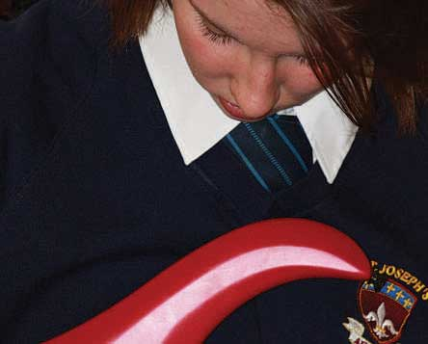
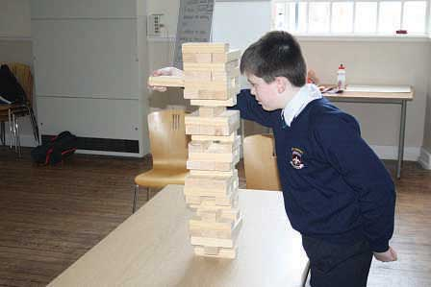
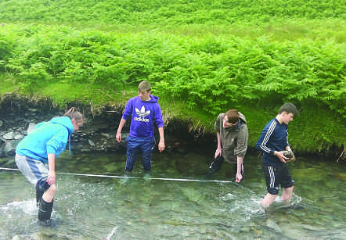
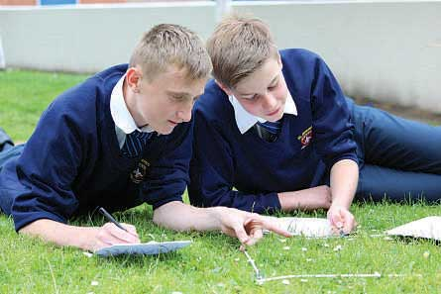

Teacher
of
Performing Arts

St Joseph’s Catholic High School - serving the community

• Judged ‘Good’ in their recent Ofsted
• Improved GCSE results
• Improved A* As
• Excellent Pastoral Care

Harrington Road, Workington CA14 3EE. 01900 873290
www.st-josephs.cumbria.sch.u

February 2018

Dear Candidates,

Thank you for expressing an interest in our school. We hope you find the information that we have provided useful. This position is a new post in school and an exciting opportunity for the right candidate to develop the Arts in school and the wider community.

We would be very pleased to arrange visits from prospective candidates or respond to calls if you require more information.

We look forward to hearing from you in due course.

Best wishes,

Jacky Kennedy
Headteacher

We have an exciting opportunity for an enthusiastic qualified teacher of Performing Arts. The successful candidate will make a significant contribution to the development of this subject across key stage 3 and 4 and will establish extra-curricular and performance opportunities for all students.

Governors and Senior Leaders are keen for this subject to nurture the talents of our wonderful students and ensure they have opportunities within the curriculum to perform, sing, dance, act or produce. We value the skills and learning experience that this subject can offer our students. To this end we require a teacher who is ambitious, forward thinking and creative and who is prepared to work with the Head of Faculty to build a successful department in the school and establish a reputation in the community for the quality of dance, drama and music.
St Joseph’s Catholic High School is a popular school. We are situated in an area of outstanding beauty on the fringes of the Western Lake District which provides a lovely place to live and work and unique extra–curricular opportunities for our students.

The Performing Arts facility is well equipped and consists of a large teaching space, a recording studio and 3 practice rooms which are used for keyboard, drums and small group work. We have 2 halls which are used for performance and rehearsal. One is fully equipped with stage lights, a sound system, screen for back projection and a multi-functional blackout curtain system, that can also be used to create a theatre black box. We have a modular stage system and tiered seating, perfect for productions and concerts. There is also a mirrored dance studio at one end of the hall. The second large venue also has stage lights and a sound system.

The school currently offers Btec Performing Arts at key stage 4 and music lessons in key stage 3. Following the retirement of the Head of Music, we are looking at appointing a full time teacher of Performing Arts to develop the Btec course further, as well as developing the schemes of work to offer all 3 specialisms of music, dance and drama to key stage 3. Initially this post will allow some additional non-contact time to dedicate towards planning and developing this new role and building up the extra-curricular aspects, but we know, that as the Btec becomes more popular the timetable will grow.

The successful applicant would ideally be a specialist in dance or music/ musical theatre and would also have a working knowledge of all disciplines involved. They will not only deliver the core curriculum but will drive after school clubs and activities in this subject. With the support of a team of staff, they will organise concerts and productions and work with our feeder schools to build and develop performing Arts.

We have a number of excellent Peripatetic teachers who deliver musical tuition on a variety of instruments to around 70 students. This includes drums, keyboard, singing, woodwind, brass and guitar. The successful applicant will have the responsibility of quality assuring their work and the organisation of their timetables. There is administrative support for part of this work.

We offer a very supportive staff community. We have dedicated CPD and or department time on a weekly basis. We ensure dedicated planning and preparation time by allocating more than the 10% normally afforded to staff.
In return the person appointed will have
• A commitment to the Catholic ethos of the school
• High standards and expectations
• Highly developed inter personal skills
• A commitment to teamwork
• A positive outlook

If you would like more information on the job or a visit to the school, please telephone Sybil Worsley, Business Manager on 01900 873290. Applications to be returned to Julie Gaffney at the school address.

Closing date :12 noon on Monday 26th February 2018.
Interviews: Friday 9th March 2018.

The school is committed to safer recruitment procedures and all applicants will be subject to an enhanced DBS.

This is not an equal opportunities school.

Person Specification for Teacher of performing Arts
 | Essential | Desirable
Qualifications/ training/ competencies | Qualified teacher status | Evidence of participation in professional development or further study
 | Relevant qualification in subject area (degree) Music | Practising Catholic
 | Teaching qualification (PGCE/Cert Ed)
Relevant experience | Outstanding teaching ability | Experience of dealing with a wide range of students and responding to their needs
 | Experience of effective team working and promoting effective relationships | Understanding and experience of exam board procedures and administration
 | Ability to use IT in teaching and administrative duties | Experience of teaching to A level
 | Ability to teach across the ability range in Key Stage 3 and 4
Knowledge | Knowledge and understanding of equality and diversity issues
 | Knowledge and understanding of different teaching strategies and ability to apply these appropriately
Skills | Excellent communication skills
 | Student focused
 | Flexible approach
 | Ability to manage time effectively and meet deadlines
 | Ability to demonstrate patience and understanding with learners
Personal Qualities | Commitment to actively supporting the school’s distinctive ethos
 | Commitment to develop Performing Arts both in the school and wider community
 | Ability to work as part of a team
 | Ambition and the capacity for hard work
 | Energy and imagination
 | A talent for motivating students across a range of abilities
 | Good organisational skills
 | Determination to achieve the very best result for every student

ST JOSEPH’S CATHOLIC HIGH SCHOOL BUSINESS AND ENTERPRISE COLLEGE
TEACHER JOB DESCRIPTION
Catholic Nature of the School;
There is an expectation that all staff up hold and support the Catholic nature of the school in all aspects of school life.

Curriculum development; The post of Performing Arts Teacher requires that this new area of the curriculum will be developed with the Faculty leader, not just for the curriculum but through extra -curricular activities. In addition to this you will be required to work with feeder Primary students developing the Arts.
You will coordinate all the peripatetic teaching and line manage the staff.
Specialism: St Joseph’s is a Business and Enterprise College and there is an expectation that all Teachers play a big role in embedding the specialism in to their subject area under the guidance of their head of Department.
Professional Attributes | Relationships with children and young people.

C1 | Have high expectations of children and young people including a commitment to ensuring that they can achieve their full educational potential and to establishing fair and respectful, trusting, supportive and constructive relationships with them
C2 | Hold positive values and attitudes and adopt high standards of behaviour in their professional role

Consistently and effectively plan lessons and sequences of lessons, to meet pupils’ individual learning needs.

2.1a | Derive your planning from the school’s agreed schemes of work or long term planning and the relevant aspects of the National Curriculum.
2.1b | Identify record and communicate learning objectives for lessons and sequences of lessons.
2.1c | Take account of the needs of individual pupils, groups or classes in your planning.
2.1d | Demonstrate progression in pupils’ acquisition of knowledge, skills and understanding in your planning of sequences of lessons.
2.1e | Make effective use of homework and other opportunities for learning outside of the classroom.

STANDARD 2.2 | Consistently and effectively use a range of appropriate strategies for teaching and classroom management.

2.2a | Understand and apply effective lesson structures, classroom organisation, teaching strategies and methods appropriate to motivate different pupils and groups of pupils.
2.2b | Use a range of strategies to ensure that there is appropriate pace and challenge in lessons for all pupils.
2.2c | Manage efficiently and creatively the full range of resources available, including adults other than teachers.
2.2d | Provide positive and targeted support for any pupils with particular learning needs.
2.2e | Set clear expectations for maintaining appropriate learning behaviour.
2.2f | Maintain high levels of behaviour and discipline, dealing promptly and effectively with misbehaviour and bullying.

STANDARD 2.3 | Consistently and effectively use information about prior attainment to set well-grounded expectations for pupils, and monitor progress to give clear and constructive feedback.

2.3a | Regularly evaluate the progress of pupils in relation to their prior attainment.
2.3b | Use analysis of data from internal school assessments and National Curriculum assessments to plan lessons and sequences of lessons.
2.3c | Use local and national comparative school data together with information about prior attainment to establish benchmarks and set targets for improvement.
2.3d | Report to colleagues on the progress of an individual, group or class, e.g. when changing classes.
2.3e | Monitor the progress of pupils through the continuous assessment of attainment against the learning outcomes set.
2.3f | Provide constructive, formative and summative feedback to pupils.
2.3g | Report to parents on the progress achieved by their child and the action required for further improvement.
2.3h | Liaise and work effectively with other professionals and agencies involved in the assessment and provision for pupils’ needs, e.g. educational psychologist and SENCO.

STANDARD 3 | As a result of your teaching, your pupils achieve well in relation to their prior attainment, making progress as good as or better than similar pupils nationally.

3a | Demonstrate that all pupils make appropriate and consistent progress against their prior attainment.
3b | Develop pupils’ literacy, numeracy and ICT skills though all subject teaching.
3c | Demonstrate that the level of pupils’ progress is as good as or better than local or national pupil performance in similar settings.
3d | Demonstrate that pupils of different background, behaviour and / or ability make appropriate progress.

STANDARD 4.1 | Take responsibility for your own professional development and use the outcomes to improve your teaching and pupils’ learning.

4.1a | Participate in and engage with school and/or external INSET and professional development activities.
4.1b | Demonstrate improvement in your teaching and pupils’ learning as a result of professional development.
4.1c | Share the outcomes of professional development with colleagues.
4.1d | Use the opportunity of changing duty, role or responsibility to develop further professional expertise.
4.1e | Take action as a result of feedback and identified development needs.

STANDARD 4.2 | Make an active contribution to the policies and aspirations of your school.

4.2a | Implement school policies and procedures consistently.
4.2b | Make an identifiable contribution to the development of school policy and practice.
4.2c | Ensure your work contributes to the school’s ability to meet its aims, vision and values.
4.2d | Contribute to team, departmental or school improvement planning.
4.2e | Demonstrate that your work contributes to the progress made by the school in achieving its priorities for development.

STANDARD 5 | Professional characteristics – how you are an effective professional who challenges and supports all pupils to do their best.

5a | Provide challenge and support to all pupils.
5b | Inspire trust and confidence in pupils.
5c | Build team commitment amongst pupils and with colleagues.
5d | Engage and motivate pupils to do their best.
5e | Demonstrate analytical thinking in your work.
5f | Demonstrate positive action to improve the quality of pupils’ learning.

Reviewed February 2018

GCSE Results:
Ours GCSE Results for the last 3 years are:

 | 2013/14 | 2014/15 | 2015/16 | 2016/17
5 A*-C (EM) | 57% | 45% | 56% | 58.7%
Progress 8 | n/a | n/a | -0.51 | -0.25

Staff development/ Career development
We are part of the Western Lakes Teaching Schools Alliance and are continuing to build on the already strong links with other schools in the area. We have dedicated time after school on a Thursday for CPD/Department meetings. This time is used for whole school training, sharing best practice and work in departments.

The development of our staff is of the highest importance and it is a strong feature of our school and many staff have benefitted from internal promotions over the years. Career development is one of our school’s priorities in the school improvement plan 2017/2018 and we will be working with each member of staff to identify where they want to be in their stage of their careers and finding opportunities to gain experience receive mentoring and training to help the individual achieve their goals.

Business and Enterprise:
The school became a Business and Enterprise College in 2003 and we were re- designated as high performing as part of our Ofsted inspection in March 2009. We were awarded the ‘Centre for Excellence in Enterprise Education’ by the University of Warwick in May 2011. We were one of the first schools to receive this award in Cumbria.

Our Business and Enterprise is delivered through the curriculum where possible; as part of our Pupil Personal Development Days and as one-off Enterprise activity days. We celebrate National Enterprise week in November through form activities; Careers talks at breakfast and lunch time; extra-curricular events after school.

We have developed many partnerships with local business and commerce that help us out with events and in curriculum areas throughout the year. We hold a work ready day with mock interviews for Year 10 pupils.

A member of the Senior Team has taken a lead role in working with the Cumbria Enterprise Learning Partnership covering Enterprise Education from 4-19. This involved working with business commerce, Secondary, Primary School and FE Colleges. We delivered training programmes and shared best throughout to schools and Colleges throughout Cumbria. This work is on-going but in a slightly different format.
Students take part in a number of external competitions throughout the year.

Conditions of Service
The above responsibilities are subject to the general duties and responsibilities contained in the statement of Conditions of Employment.

These duties may be amended as necessary at the discretion of the Headteacher in light of the future development of the school.

The creation of a truly Christian environment in which the Gospel is lived and experienced by all members of its community, is the central aim of St Joseph’s. All applicants are expected to be supportive of this central aim.

Features of West Cumbria
The School is situated at the western fringe of the Lake District National Park.
Many staff choose to live locally and enjoy a rural lifestyle in towns such as Cockermouth, Keswick and the villages in West Cumbria.

Housing and rented accommodation are generally readily available at prices which are lower than urban and city locations.

The school exhibits all the advantages of a smaller comprehensive school. Children are known by name by all, standards of discipline and the quality of staff pupil relationships is excellent.

Closing date for applications is Noon on Monday 26th February 2018, interviews to be held on Friday 9th March 2018.

Our School Mission Statement

AT ST. JOSEPH’S CATHOLIC HIGH SCHOOL
WE WILL CHALLENGE YOU TO AIM HIGH, WE EXPECT YOU TO SUCCEED

LIVING LOVING LEARNING

All members of the school community – pupils, staff, governors and parents – will be united in sharing a common purpose: to achieve their personal best, to pursue lifelong learning, to develop and model respect for themselves and others and lay a significant role in the life of the local community; and they will be able to articulate this common purpose and support each other to achieve these goals.

LIVING LOVING LEARNING

Our School will be characterised by positive, appropriate, productive and warm relationships all of which are at the heart of our faith. We will encourage all members of the community to reflect on and develop their relationships with each other to promote tolerance and understanding.

LIVING LOVING LEARNING

All members of the school community will strive to achieve excellence – their personal best in all areas of school life; academically, in extra-curricular activities and through their embodiment of positive attitudes and qualities.

Living, Loving and Learning through Christ

