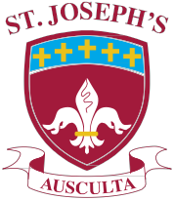**St. Joseph’s**

Catholic High School

Business & Enterprise College

# 18th January 2019

Dear Parent/Guardian

**Year 10 Progress Evening – Thursday 24th January 4.00 – 6.30pm**

You are cordially invited to the Year 10 Progress Evening which takes place on Thursday 24th January,

please arrive and sign in by 6pm to ensure that you have time to see your child’s teachers.

This is a really important opportunity to discuss current predictions with each teacher in order to best prepare for summer 2020.

As there is only 18 months left before the exams begin, we would strongly encourage you to attend with your son/daughter.

We look forward to seeing you on the 24th January.

Yours faithfully

## Miss J Kennedy

## Headteacher

Headteacher: Miss J.A. Kennedy BA (Hons)

Harrington Road , Workington, Cumbria CA14 3EE Tel: (01900) 873290

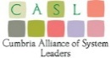   [Email: offic](mailto:office@st-josephs.cumbria.sch.uk)[e@st-josephs.cumbria.sch.uk](mailto:e@st-josephs.cumbria.sch.uk)

[www.st-josephs.cumbria.sch.uk](http://www.st-josephs.cumbria.sch.uk/)

**Living, Loving and Learning through Christ High Challenge • High Expectations • High Aspirations**