St Joseph’s Catholic High School

Admission Policy

“Living, loving, learning – through Christ”

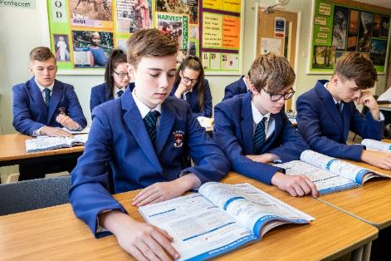
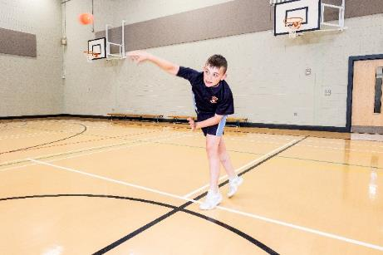

Document Control
Author | Headteacher
Version | 1.0
Status | 2022.23
Publication Date | Annually
Approved by | Governors
Approval Date
Distribution | Please note that, if printed, this may not be the most up to date copy and may not contain the latest updates.

REVIEW SHEET
The information in the table below details earlier versions of this document with a brief description of each review and how to distinguish amendments made since the previous version date (if any).

Version Number | Version Description | Date of Revision
1 | Original

St Joseph’s Catholic High School Admissions Policy
and arrangements for 2022-2023

Introduction
St Joseph’s Catholic High School is a Catholic School in the trusteeship of the Diocese of Lancaster. It is maintained by [Name of local authority] and is a voluntary aided School. Governing Body is the Admissions Authority and is responsible for taking all decisions on applications for admissions. The co-ordination of admissions arrangements is undertaken by the Local Authority.
For the school’s year commencing September 2022, the Governing Body has set the number of children to be admitted to Year 7 to be 150.
The school’s role is to participate in the mission of the Catholic Church by providing a curriculum, including Catholic religious education and worship, which will help children to grow in their understanding of the Good News and in the practice of their faith. The school will help the children develop fully as human beings and prepare them to undertake their responsibilities as Catholics in society. The school requires all parents applying for a place here to understand and respect this ethos and its importance to the school community. This does not affect the rights of parents who are not of the Catholic faith to apply for a place here.
ADMISSIONS TO THE SCHOOL will be determined by the Governing Body. Parents must complete a Local Authority Preference Form or apply online via the website www.cumbria.gov.uk/childrensservices/schoolsandlearning/lss/schooladmissions.asp If you wish to have your application considered against that school's religious criteria then you must ALSO complete the Supplementary Form which is available from the school.
As required by law, all children with a Statement of Special Educational Needs and/or Education, Health and Care Plan naming the school will be admitted before the application of the oversubscription criteria.

Admissions/Oversubscription Criteria

The Governors will admit up to 150 children in September 2022. If there are fewer than 150 applications, all applicants will be offered places. If there are more applications than the number of places available, the following oversubscription criteria will be applied:

- Looked After Children and previously Looked After Children

- Baptised Catholic Children who currently attend St Gregory’s, St Mary’s, St Patrick’s, Workington, St Joseph’s, Cockermouth or Our Lady & St Patrick’s, Maryport Catholic Primary Schools.

- Baptised Catholic Children who will have a brother or sister in the school at the time of admission giving priority to those children with the youngest sibling.

- Baptised Catholic Children living within the parishes of Our Lady & St Michaels, St Gregory’s, St Mary’s, Our Lady & St Patrick’s or St Joseph’s, Cockermouth.

- Other baptised Catholic children.

- Children who currently attend a Catholic primary school.

- Children who will have a brother or sister in the school at the expected time of admission giving priority to those children with the youngest sibling.

- Children of staff at the school may be conferred where the member of staff has been employed at the school for two or more years at the time the application is made or the member of staff is recruited to fill vacant post where there is a demonstrable skill shortage.

- Children who attend a ‘faith based Primary school’.

- Children who are baptised in or are members of other Christian denominations and which is supported in writing by a Certificate of Baptism and/or letter from their minister.

- Children living nearest the school. Distance measurements will be undertaken using the Local Authority’s computerised Geographical Information System (GIS) and will be to the nearest entrance on the school site which is available to pupils at the time of undertaking the assessment. The route used will be the shortest walking route by road as identified by GIS at that time.

Note:

If it is necessary to prioritise between applications within any category the distance criteria referred to in criterion 11 will be used.

Explanatory Notes

Notes for Applicants:
a. All applications will be considered at the same time and after the closing date for admissions. Applications received after this date will be treated as a late application and will not be considered until after the main allocation of places has taken place.
b. A Looked After Child is a child who is (a) in the care of a Local Authority, or (b) being provided with accommodation by a Local Authority in the exercise of their Social Services functions (under section 22(1) of the Children Act 1989. A previously Looked After Child is one who immediately moved on from that status after becoming subject to an adoption, residence or special guardianship order.
- For a child to be considered as a Catholic evidence of a Catholic Baptism is required.
A person who has been baptised in a separate ecclesial community and subsequently received into full communion with the Catholic Church by the Rite of Reception of Baptised Christians into the Full Communion of the Catholic Church. Written evidence of their reception into full communion with the Catholic Church can be obtained by recourse to the Register of Receptions, or in some cases a sub-section of the Baptismal Registers of the Church in which the Rite of Reception took place.
The Governing Body will require written evidence in the form of a Certificate of Reception before applications for school places can be considered for categories of ‘Baptised Catholics’. A Certificate of Reception is to include full name, date of birth, date of reception and parent(s) name(s). The certificate must also show that it is copied from the records kept by the place of reception.
Those who have difficulty obtaining written evidence of baptism for a good reason, may still be considered as baptised Catholics but only after they have been referred to the parish priest who, after consulting with the [appropriate diocesan authority] will decide how the question of baptism is to be resolved and how written evidence is to be produced in accordance with the law of the Church.
d. Home Address is considered to be the address where the child normally lives. Where care is split and a child moves between two addresses, the household in receipt of the child benefit would normally be the address used but the admission authority body reserves the right to request other evidence as fit the individual circumstance. Applicants should not state the address of another relative or person who has daily care of the child.
- ‘Sibling’ is defined in these arrangements as full, half or step brothers and sisters, adopted and foster brothers and sisters who are living at the same address and are part of the same family unit. This does not include cousins or other family relationships.
- Where there are twins or multiple birth children wanting admission and there is only one single place left within the admission number, then the Governing Body will exercise as much flexibility as possible. If places for both twins or all triplets etc cannot be offered, the family will be advised accordingly. This may also apply to siblings who are in the same year group. If one a single place can be offered then it will be up to parents to decide when they wish to accept the place offered.

- A waiting list for children who have not been offered a place will be kept and will be ranked according to the Admission Criteria. The waiting list does not consider the date the application was received or the length of time a child's name has been on the waiting list. This means that a child's position on the list may change if another applicant is refused a place and their child has higher priority in the admissions criteria.
- For ‘In Year’ applications received outside the normal admissions round, if places are available they will be offered to those who apply. If there are places available but more applicants than places then the published oversubscription criteria will be applied. Admissions in year will be placed at the beginning of the term if in provision.
- If an application for admission has been turned down by the Governing Body, parents may appeal to an Independent Appeals Panel. Parents must be allowed at least twenty school days from the date of notification that their application was unsuccessful to submit that appeal. Parents must give reasons for appealing in writing and the decision of the Appeals Panel is binding on the Governors.
- The Governing Body reserve the right to withdraw the offer of a school place where false evidence is received in relation to the application.

