**English Key Information**

***‘Don’t tell me the moon is shining; show me the glint of light on broken glass’***

***‘Books are uniquely portable magic’***

***‘A reader lives a thousand lives before he dies’***

**English department aims and ethos:**

The English department enhance students’ lives in the study of English Language and literature by fulfilling the St Joseph’s Mission statement; Living, loving, learning through Christ and promoting our virtues. We strive to make learning fun, inspire a love of reading and a thirst for knowledge in our students, developing them as independent and enquiring learners. In order to achieve our aim, we endeavour to:

• Ensure all students make outstanding progress.  
• Ensure all English lessons include relevant challenge, pupil engagement and a focus on celebrating success.  
• Provide all students with the opportunity to study a wide range of engaging fiction and non-fiction texts to help develop insightful and perceptive readers.  
• Promote independent reading time and develop a love of reading with all students to encourage them to read for pleasure and become lifelong ‘readers’.  
• Provide students opportunities to participate in a wide range of learning experiences, developing them as effective communicators and active learners.  
• Help all students develop into creative, analytical and independent thinkers.  
• Encourage all pupils to develop skills to enable them to write, read and speak Standard English fluently and accurately.  
• Enable all students to develop effective writing skills so that pupils can express themselves precisely and fluently in a range of forms, for different purposes and audiences, communicating meaning and developing ideas effectively and controlling grammar and structure appropriately.  
• Provide a supportive, engaging and challenging learning environment to help students achieve their very best.  
• Provide students with opportunities to develop Oracy skills and develop their confidence when taking part in public speaking.  
• Prepare students for the world of Higher Education and work by guiding them to successful assessment at GCSE and raising their aspirations.

**Meet the English department:**

Mrs Steele - Co-Head of English  
Mrs Kim - Co-Head of English  
Mrs Fillingham - Assistant Head and English Teacher  
Mrs G Ward – English Teacher  
Miss C Fisher – English Teacher  
Mrs A Mitchell – English TA and Reading Intervention Lead

**KS4 Curriculum**

At KS4, all students study the AQA English Language and English Literature GCSE courses.

**English Literature:**

In AQA GCSE English Literature, students will sit two examinations.

**English Literature Paper 1:**

Shakespeare and 19th -century novel  
• ‘Romeo and Juliet’  
• ‘A Christmas Carol’ or ‘Jekyll and Hyde’ (text choice at the teacher’s discretion)  
• Total marks for this paper is 64

**English Literature Paper 2:**

Modern texts and poetry  
• Blood Brothers by Willy Russell  
• AQA Power and Conflict anthology.  
• Total marks for this paper is 96

**English Language:**

In AQA English Language, students will sit two examinations.

**English Language Paper 1:**

Explorations in creative reading and writing.

• In section A of this paper, students will use their analytical skills to analyse a writer’s use of language and the impacts/effects from an unseen fictional extract.  
• In section B of this paper, students will demonstrate their understanding of the effective use of language to produce a piece of fiction of their own.  
• Total marks of this paper is 80.

**English Language Paper 2:**

Writers’ viewpoints and perspectives.

• In section A of this paper, students will use their analytical skills to analyse two non-fiction texts from different time periods. Students will be required to synthesise, analyse and compare writers’ methods across both non-fiction extracts.  
• In section B of this paper, students will demonstrate their understanding of non-fiction features of writing to produce their own piece of non-fiction writing to express a viewpoint/perspective.  
• Total marks of this paper is 80.

**KS3 curriculum:**

Our KS3 is developed in order for students to broaden their cultural capital and understanding of the world around them through our carefully planned curriculum and carefully chosen texts. The KS3 curriculum follows a thematic thread across Year 7, 8 and 9 with interlinking themes and concepts.

• In Year 7, the curriculum is planned around the theme of ‘identity’.  
• In Year 8, the curriculum is planned around the theme of ‘power’ and exploring those in society who are ‘powerful and powerless’.  
• In Year 9, the curriculum is planned around the theme of ‘injustice’.

**Texts studied in Year 7:**

• Poetry from other cultures.  
• ‘The Paradise Carpet’ by Jamila Gavin  
• ‘A Midsummer Night’s Dream’ by William Shakespeare

**Texts studied in Year 8:**

• ‘Animal Farm’ by George Orwell or ‘The Hunger Games’ by Suzanne Collins  
• Famous speeches by Martin Luther King Jr, Malala Yousafzai and Greta Thunberg.  
• ‘Macbeth’ by William Shakespeare.

**Texts studied in Year 9:**

• Extracts from ‘Frankenstein’ by Mary Shelley.  
• ‘The Long Way Down’ by Jason Reynolds.  
• Non-fiction articles surrounding gun violence, knife crime and gang culture in the UK and USA.  
• ‘An Inspector Calls’ by J.B. Priestley

 Skills the students will develop:

• Deduction and inference skills.  
• Analytical skills.  
• Oracy skills  
• Writing skills  
• Key component knowledge in all year groups.  
• Understanding and application of core vocabulary.

**Future careers and vocations:**

• Lots of students move on to study A Level English Language and/or English Literature, some students then procced to degree courses.  
• In terms of careers, English opens many doors for students and GCSE English Language and Literature are both highly valued in many fields, including:  
Teaching, journalism, law, politics, publishing and media, marketing and HR.

**Assessment and progress in English:**

Students in both KS3 and KS4 complete regular formative and summative assessments in English. Following the marking of the completed assessments, students spend a lesson reflecting and improving on their work through designated DIRT time. This is evidenced in their books in green pen.

Directed

Improvement

Reflection and rewriting

Time

Assessments in English take a variety of forms. Assessments are a mixture of reading, writing and oracy with inbuilt key component knowledge quizzes which are low-stakes.

**Rewards in English:**

Students in English are rewarded every week with ‘Student of the Week’. Teachers nominate and award students with ‘Student of the Week’ not only for their academic success, but for their attitude to learning, their eloquence and displaying the St. Joseph’s values of faith, hope and love within English.

**Interventions in English:**

Within English, we offer a multitude of interventions to help promote progress and student confidence.

At KS3, we offer reading and phonics interventions to help support our students with decoding and comprehension skills not only in English, but across the curriculum.

At KS4, we offer targeted intervention sessions based on current and predicted GCSE grades to ensure students are given the best opportunity to meet their potential and beyond. These intervention tuition sessions take place with a designated teacher within the English department and run throughout the year until the completion of their English GCSE course.

On the morning of GCSE examinations, all English staff also host revision breakfasts. sessions

**Contacts:**

Amy.fillingham@sjchs.uk

Gemma.ward@sjchs.uk

MiHwa.Kim@sjchs.uk

Ellie.steele@sjchs.uk

Catherine.fisher@sjchs.uk

Alyson.mitchell@sjchs.uk

**Enrichment**

Our English enrichment booklets provide our students with a wide range of texts and media resources relating to the topic they learn in curriculum time. Our choice of enrichment resources exposes students to different styles of writing and information that we don’t cover in lessons which will enable students to further develop their knowledge about the topic and challenge their thoughts and ideas.

**All enrichment booklets for KS3 and KS4 can be found on the English SharePoint -** [**English Department (sharepoint.com)**](https://stjosephscatholichigh.sharepoint.com/sites/english)

**Competitions**

The English department are renowned for our competitive streak in order to raise engagement and aspirations. Here’s an example of the enrichment competitions we host:

• KS3 Christmas creative writing competition

• Rotary ‘Young Writer’s’ competition

• ‘Above and Beyond’ KS3 competitions for students who are going above and beyond the learning in the classroom.

• ‘Readathon’ for World Book Day to support the Read For Good charity.

• ‘The Big Book Quiz’ is hosted in partnership with World Book Day and is an interform competition in Year 7.

• From September 2023, we will be introducing the St. Joseph’s ‘Spelling Bee’ which will be held twice a year. The first stage will be a competition held within each year group in the autumn term. The second stage in the spring term will be where each year group will compete against each other for the winning title.

**Extra-Curricular Clubs**

• Reading club hosted by Mrs Mitchell Monday and Tuesday P4a in the library.

• Handwriting support club with Mrs Kim.

• Debate club with Miss Fisher.

**Cultural enrichment experiences**

• Theatre visits to watch performances of key texts at KS3 and KS4.

• Annual workshops delivered by Wordsworth Trust.

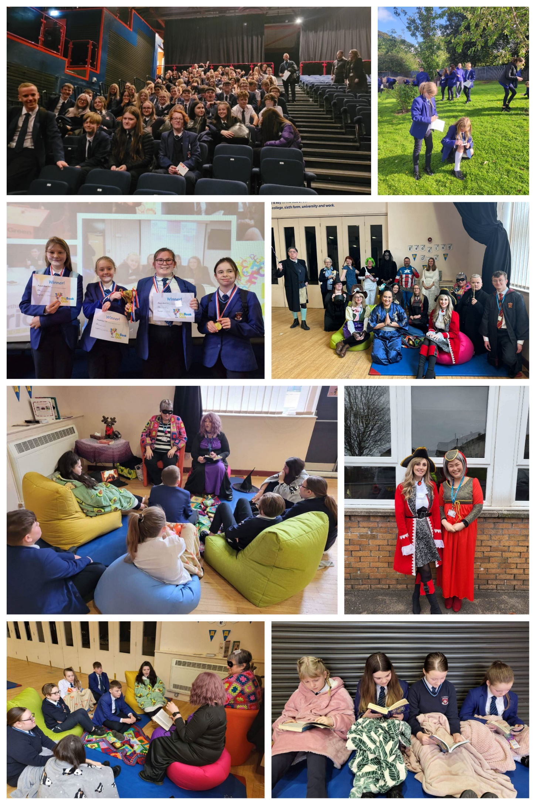

**Reading**

Reading for pleasure at St. Joseph’s:

At St. Joseph’s, one of our key priorities is to foster a love of reading in our students and to equip students with the knowledge and skills to becoming a lifelong reader.

To promote this, we have suggested reading lists for KS3 and KS4 which can be found here:

[KS3 Recommended Reading Lists PDF.pdf](https://stjosephscatholichigh-my.sharepoint.com/:b:/g/personal/ellie_steele_sjchs_uk/EfVM8TNdnyBMkz4UTwldUp8By5D8YLD2knk9IV62ws7GTg?e=FY5Dbx)

[KS4 Recommended Reading lists PDF.pdf](https://stjosephscatholichigh-my.sharepoint.com/:b:/g/personal/ellie_steele_sjchs_uk/EQ_1zTHBOuZIl7KcS5u59ukBKwwfI9idtZtAuqmBcdz7qg?e=bSekfD)

We also promote a ‘Book of the Month’ which is readily available within our library for students to read.

All staff advertise what they are currently reading on their classroom doors and on their email signatures which has been a successful way of sparking important discussions about reading between staff and students.

**Reading in form time:**

All students at St. Joseph’s complete reading activities in form time to begin their day. Students are exposed to a range of fiction and non-fiction texts to help expand their reading skillset, cultural capital and knowledge of the world around them. Staff guide the reading in form time by implementing Reciprocal Reading strategies to aid the understanding of texts through the use of predict, clarify, question and summary.

**Reading for pleasure in lessons:**

• All KS3 students have a reading lesson with Mrs Mitchell. Students will use reciprocal reading strategies guided by Mrs Mitchell to read for pleasure and develop their independent reading skills. The texts for KS3 reading lessons are carefully chosen to complement what students are studying in their core English lessons to broaden their conceptual and thematic understanding.

**Reading interventions**

Mrs Mitchell oversees reading intervention within English. Mrs Mitchell uses her expertise in phonics and reciprocal reading to hold targeted intervention sessions with students who are below in their reading age, or who have been identified as having gaps in their phonics and decoding skills.

Mrs Mitchell’s interventions have had a significant impact on the reading progress of our students and is a valued intervention here at St. Joseph’s.

All reading interventions are one to one or small group and are held in Mrs Mitchell’s wonderful reading room.

From September 2023, we will be embarking on a ‘paired reading’ intervention whereby our strong readers at KS4 will help support and mentor readers in KS3 as an additional intervention amongst peers.

**Testimonials from students who have received reading interventions:**

**“Phonics has helped me read more fluently; it has helped me to pronounce words better”**

(Year 9 student)

**“It was good. It helped remind me about the phonic sounds from primary school. I would tell friends to do it if they have chance.”**

(Year 9 student)

**“The phonics has helped me a lot, it has helped me understand word sounds and how to use them to form words. I would tell friends to give it a go if they can.”**

(Year 10 student)

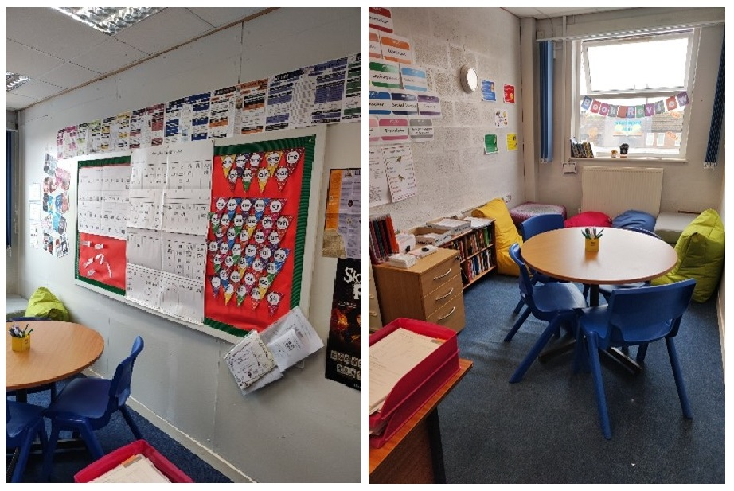

**Resources**

**Websites**

• [English Department SharePoint](https://stjosephscatholichigh.sharepoint.com/sites/english)

• [SENECA](https://senecalearning.com/en-GB/)

• [Goodreads](https://www.goodreads.com/)

• [Wordle](https://www.nytimes.com/games/wordle/index.html)

• [BBC Bitesize](https://www.bbc.co.uk/bitesize/subjects/zt3rkqt)

• Youtube

[Mr Bruff: Mr Bruff](https://www.youtube.com/channel/UCM2vdqz-7e4HAuzhpFuRY8w)

[Stacey Reay: Stacey Reay](https://www.youtube.com/channel/UCJhuqpyhE8NzYZFkwTzi_7g)

• [British Library](https://www.bl.uk/)

• [Massolit](https://www.massolit.io/)

**Multimedia:**

• There are links on ‘stream’ for film adaptation of all of the KS4 literature texts students’ study.

• KS4 students can access ‘GCSEPod’ via the English SharePoint

• Access to National Theatre online (log in details are sent out to both students and parents in the ‘Welcome to English’ email at the beginning of September)

• At KS3, there are links to film versions of the two Shakespeare plays, the Hunger Games which Yr8 students’ study and there is the audio version of the Yr9 text ‘A Long Way Down’

Please Click the following links to view the Learning Journey Roadmaps:

[English_Learning Journey](https://sjchs.uk/wp-content/uploads/English_Learning-Journey.pdf)