**MFL Key information**

**"One language sets you in a corridor for life.  Two languages open every door along the way." - Frank Smith, Canadian psycholinguist**

At SJCHS the purpose of studying foreign languages is to provide students an opening to other cultures. Languages are part of the cultural richness of our society and the world in which we live and work. Learning languages contributes to mutual understanding, a sense of global citizenship and personal fulfilment. The ability to understand and communicate in another language is a lifelong skill for education, employment and leisure in this country and throughout the world. Learning languages gives pupils opportunities to develop their listening, speaking, reading and writing skills and to express themselves with increasing confidence, independence and creativity. They explore the similarities and differences between other languages and English, alongside learning how language can be manipulated and applied in different ways.

The development of communication skills, together with understanding of the structure of language, lay the foundations for future study of other languages, and supports the development of literacy skills in a pupil’s own language.

The MFL department believe that a high-quality languages education will foster a pupil’s curiosity and deepen their understanding of the world. Our teaching aim is to enable pupils to express their ideas and thoughts in another language, and to understand and respond to its speakers, both in speech and in writing. It also aims to provide opportunities for them to communicate for practical purposes, learn new ways of thinking, and read great literature in the original language. Our language teaching purpose is to provide the foundation for learning further languages, equipping pupils to study and work in other countries.

At St Joseph's your child will study Spanish from Year 7 to Year 9, with the option to complete a GCSE in year 10 and 11. In Year 8, your child will have the opportunity to visit Spain on our annual school trip to either Madrid or Barcelona!

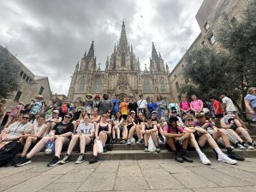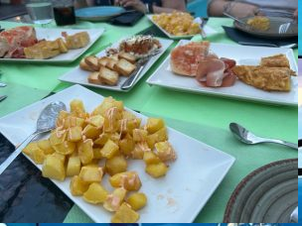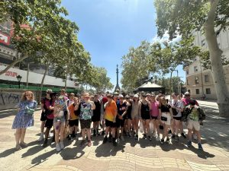

Course followed/Exam board

(KS3 and KS4)

We broadly follow the Pearson’s Viva textbooks from year 7 to year 11 and we regularly top up with our own resources, and materials from a wide range of electronic platforms that we subscribe to.

At KS4, we prepare students to sit the AQA GCSE Spanish examinations.

**Skills the students will develop**

In MFL students develop strong cognitive skills (the core skills our brain uses to think, read, learn remember, reason and pay attention) such as mental flexibility, listening skills and problem solving.

Learning a language helps pupils boost their memory, develop their communication and oracy skills, and build their confidence, resilience and coping skills when faced with the unfamiliar or unknown.  Learning a new language helps students become more tolerant of people who are different and to see things from other’s point of view. Ultimately, all these build on and develop the social and employability skills of young people.

Future careers and vocations

Contrary to popular belief, languages do not limit students to careers in translating, interpreting, education or tourism industries. The ability to speak a language is highly regarded and often necessary for professional progression and success in many sectors such as insurance and finance, law, food and drink, sales and marketing, and for international companies and organisations such as the UN, Greenpeace, Doctors without borders and the Enterprise and Diplomatic Service amongst many others. In general terms, if we have money to spend, everyone will speak English to us but if we need something or have a product or service to sell, we need to be able to speak other people’s language.

Contacts

Head of department: [rebekah.birkett@sjchs.uk](mailto:rebekah.birkett@sjchs.uk)

**Enrichment**

**Competitions**

* EDL (European Day of Languages) - quizzes
* Día de los Muertos (Day of the dead) - Papel picado
* Blooket quizzes
* Memrise points
* Sentence builders inter-class competitions
* Steal my sentence
* One pen one dice

**Reading**

**Reading for pleasure**

Cuentos en español (bilingual short stories)

**Academic Reading**

Viva 1, Viva 2, Viva GCSE Spanish (Pearson’s textbooks)

AQA GCSE Spanish Grammar and translation

**Reading for parents**

Spanish in three months (Hugo) - It won’t get you talking Spanish but would help you understand basics

**Resources**

**Websites & Multimedia**

* [www.sentencebuilders.com](http://www.sentencebuilders.com/)
* [www.memrise.com](http://www.memrise.com/)
* [www.senecalearning.com](http://www.senecalearning.com/)
* [www.wordwall.net](http://www.wordwall.net/)
* [www.studyspanish.com](http://www.studyspanish.com/)
* [www.pearsonactivelearn.com](http://www.pearsonactivelearn.com/)
* [www.teachvid.com](http://www.teachvid.com/)

Please Click the following links to view the Learning Journey Roadmaps:

[French Learning Journey](https://sjchs.uk/wp-content/uploads/French_Learning-Journey.pdf)

[Spanish Learning Journey](https://sjchs.uk/wp-content/uploads/Spanish-Learning-Journey-1.pdf)