Performing Arts Key Information

***“A film, a piece of theatre, a piece of music or a book can make a difference. It can change the world.*” Alan Rickman**

Performing Arts is an important subject for developing many skills including confidence and independence, both valuable life skills. In Performing Arts, students are encouraged to explore a range of skills and activities whilst studying Music, Dance and Drama. Good communication, teamwork and creativity are key to success in this area.

The department consists of 2 teaching staff, Beth and Alex Clark

At KS4 we follow the Eduqas Level 1/2 Vocational Award in Performing Arts

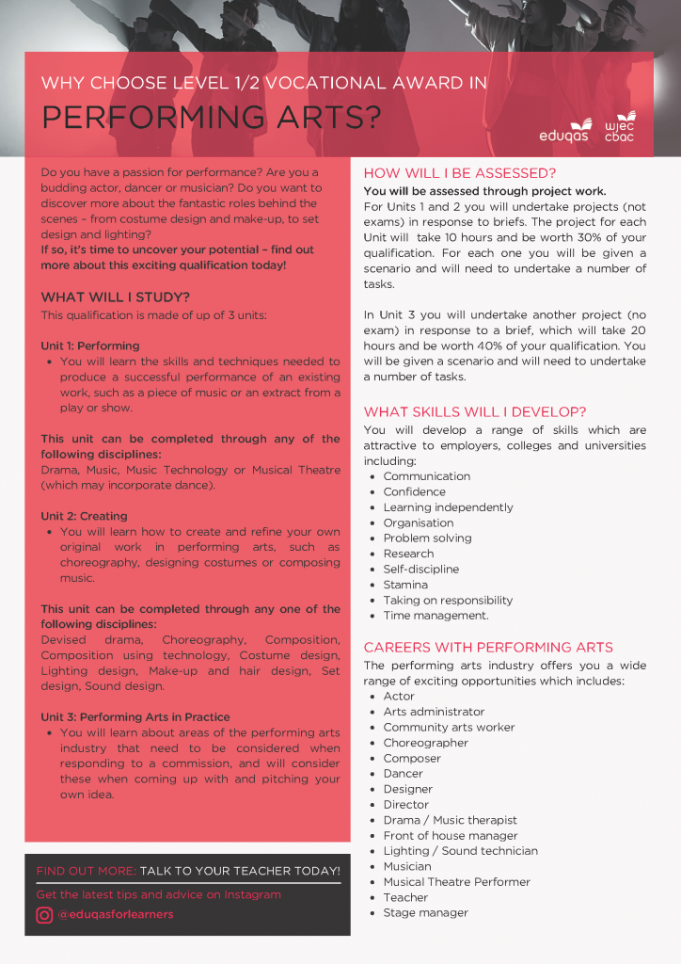

In KS3, students study a varied curriculum covering Music, Dance and Drama skills. Music is studied consistently throughout the year, complimented by Dance or Drama. In Music, skills are developed in composition and performance. In Dance, students learn how to choreograph dance as well as performance skills. Drama skills are developed through performance and script writing.

Many transferable skills are learnt and developed in Performing Arts. These include independent learning, group work, confidence, vocal projection and performing skills.

Students can go on to study Performing Arts at Sixth Form or college and then on to degree level. A qualification in Performing Arts can support many careers, especially those that involve public speaking and forward-facing work.

To contact us please email gemma.daviessjchs.uk

Enrichment

Competitions

* Annual Talent Show

Extra-Curricular Clubs

* Singing group
* Band
* Dance club

Shows/Other Events

* Annual Musical
* Christmas Showcase
* Summer Showcase
* Community performances
* Primary workshops

Reading

Reading for pleasure

Students are encouraged to read for pleasure, relating to topics studied in class

Academic Reading

Students read scripts in Drama work which includes analysis tasks

Resources

Websites

A variety of websites are used at different points of the curriculum, which are shared with pupils when relevant

Multimedia

* Sibelius
* Audacity
* We also use recording facilities when applicable, to support the music curriculum

Please Click the following links to view the Learning Journey Roadmaps:

[Performing Arts Learning Journey](https://sjchs.uk/wp-content/uploads/Performing-Arts_Learning-Journey.pdf)